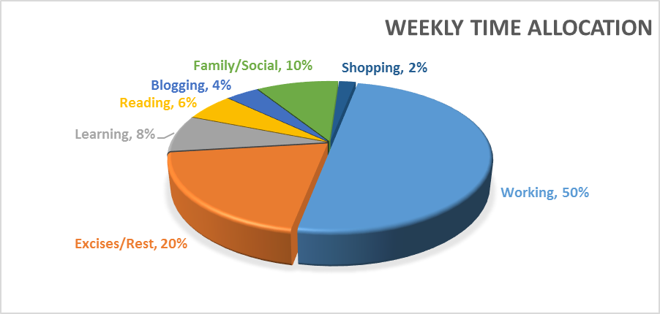
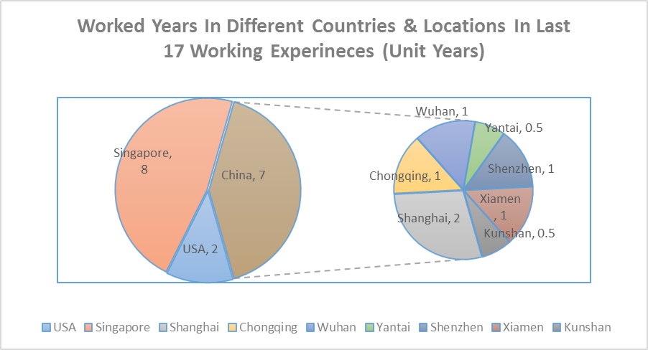
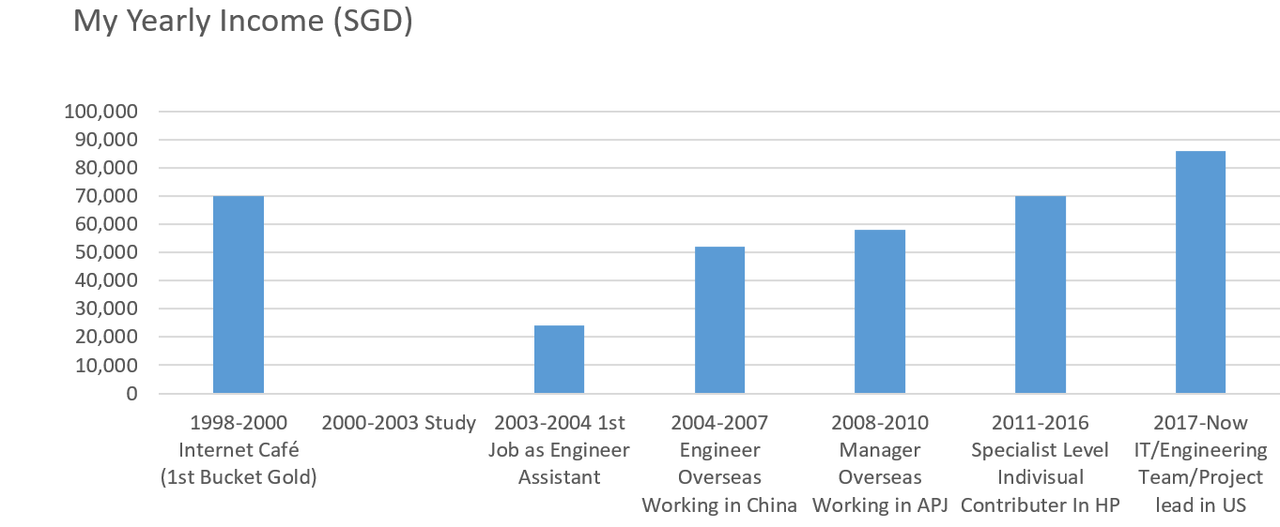
Milestone.
Y1998-1999 China
Setup my own business (20 PCs Internet café).1st Bucket Gold
Y2000-2003.Singapore Nanyang Polytechnic
Nanyang Polytechnic(NYP)
Diploma in Manufacturing Engineering
Y2003-2004 Singapore
Join Mentor Media
Working as Process Engineer
Y2004-2008China/Shenzhen
Work in Mentor Media
Working as Process/IT Engineer
Y2009-2011.7China/Shanghai
Work in Mentor Media
Working as IT/Engineering Manager
Y2011.7-2016.12 Singapore
Join HP (Hewlett-Packard)
Working as SME in WW Process and Capability Team under technology operation
Y2013-2015. Oxford Brookes University
Bachelor of Science (HONS) IN Information Systems & Software Engineering.
Y1995-1998.Jilin High School
High School
Piano Grade 9
China University Exam 512.3
Y2017.2 –2018.8USA
Mentor Media California
Working as Tech Lead in IT/Engineering
Y2006.Microsoft Pro. China
MPC (Microsoft Professional Certificate)
Y2018 9 – NowSingapore
FTDI
Working as IT Manager in (IT/Sales Operation/BI)
Y2019-2020.11 Coventry University
Master of Science in Engineering Business Management
[Education/Training]
[Professional Experience]
Married in Shanghai - 2009.
I, Born in 1979.
1st Son Born in Singapore- 2014
Timeline
To be Continued

Skillset Self-Evaulation

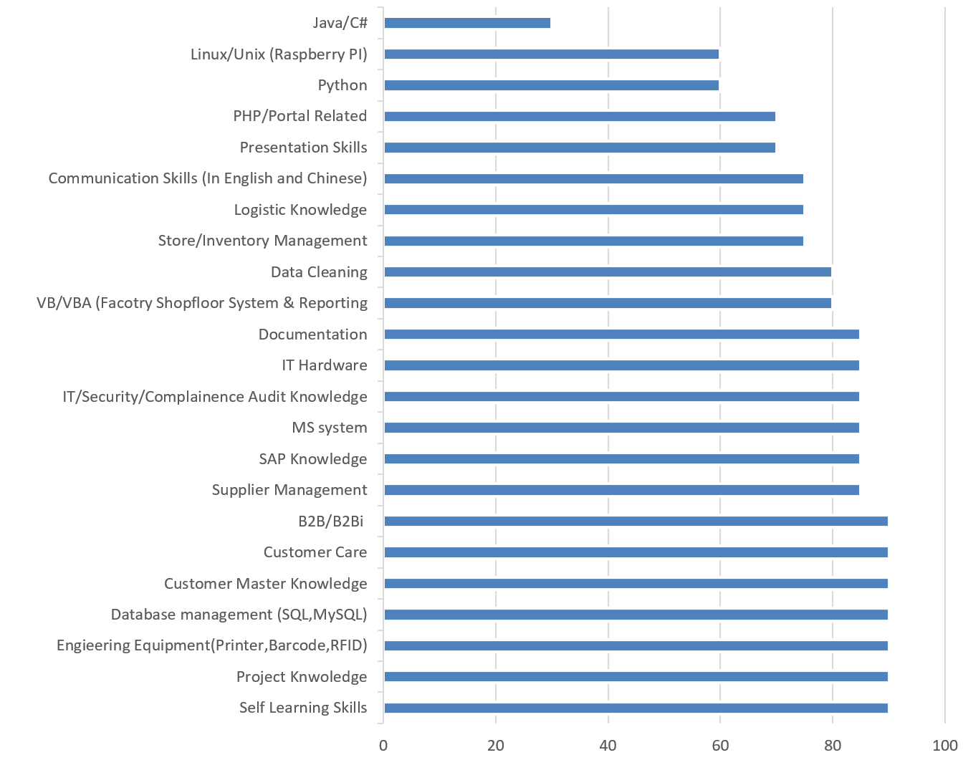
------END------

